
投標注意事項:
Bidding Documents Submission Notice:

- 請將所有投標文件備妥並密封於信封內。
Please make sure you have all bidding documents ready, and make sure your tender is in a sealed envelope.
- 請將外標封黏在快遞信封外如圖示。
Please paste our cover sheet on the outside of a forwarder’s envelope as below.
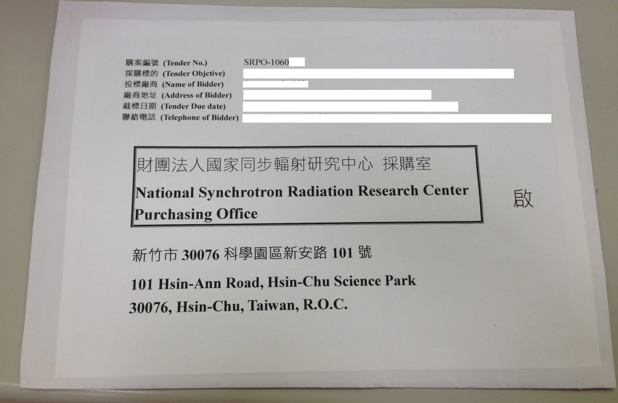
- 本案須檢附以下投標文件:
This required bidding document includes:
■設立登記證明
A Certificate of registration or establishment documents of under applicable law in your country
■用印之標價清單
A signed Submitted Proposal Price List with your Bid Price
■投標廠商代理人授權書1份
A well filled-in Power of Attorney with the seal of tenderer or its Responsible Person, or with the signature from authorized person of foreign Tenderer
■請列印「廠商投標文件審查表」、填寫公司
名稱並檢附相關文件。
Please fill in company name on page 1 of “Bid Documents Evaluation Form for Tenderer” and enclose the required certificates/documents in order.

- 請於截標前將投標文件送達本中心。
Please submit your documents to NSRRC by closing deadline, 05:00 pm, June 17th, 2026 (Taipei Time).

※ 請留意投標文件逾期將不予受理。
Please note a late tender will not be considered.

Kind regards,

Kate Hsu
Procurement Office
Tel:+886-3-5780281 ext:8406
E-mail address: hsu.tw@nsrrc.org.tw

